**Introduction to Terraform on AWS**

[Terraform AWS Workshop-Project]

**Introduction - Scenario**

In this project, I will use Terraform as the Infrastructure as Code (IaC) tool to deploy a highly available Wordpress application in a single region. It will be configured to leverage a Multi-AZ (data replication across multiple AZs) MySQL database and an auto-scaler based on CPU utilization for web hosting.

**Architecture - Overview**

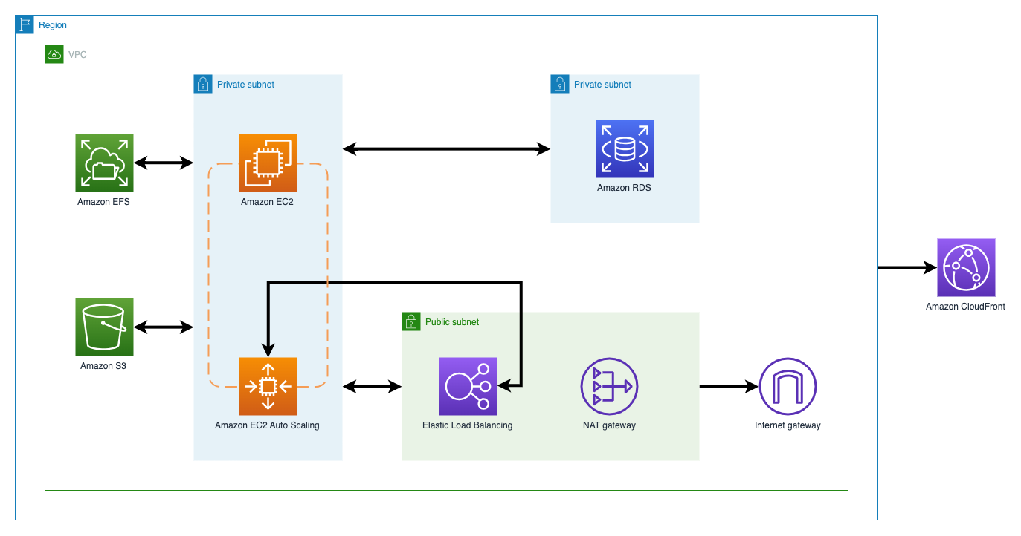

**Environment Configuration Set-Up**

Link: <https://static.us-east-1.prod.workshops.aws/public/3a811ff3-2be5-4d8f-80a8-85b21ca5b5e4/assets/terraform.zip>

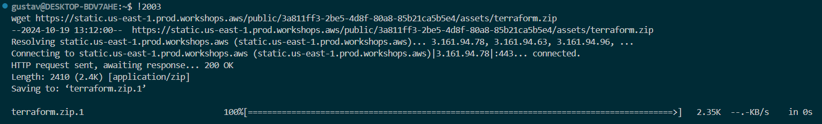

**Update the input variables, provider, local values, and data sources -Folder Structure.**

**Providers, Resources, and Data Sources – eg:**

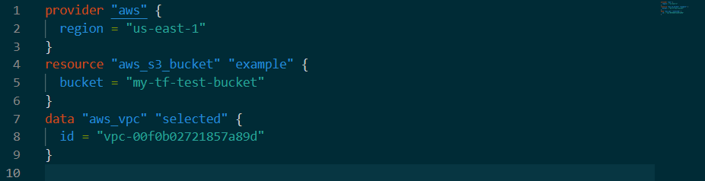

**Data sources**

**Creating Resources for IAM**

This will allow the EC2 instance to read from the S3 bucket and get full access permissions to the RDS resource.

Updating the main.tf appending IAM roles and instance profiles from the **Data sources**.

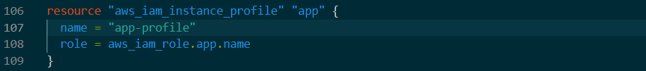

**Terraform Initialized**

**Successful creation of the iam role and instance profiles**

**Creating Networking Resources**

Updating the main.tf appending the networking content, such as the subnets, internet gateway, route tables and NAT gateway.

**Subnets**

**Nat gateways**



**Creating Security Resources**

Updating the main.tf appending the security content.

**Security Groups**



**Endpoints**

**Creating Application Resources**

This will create the RDS MySQL database, a load balancer, an autoscaling group, an EFS file system, an S3 bucket.

Updating the main.tf appending the application content

**Console view of created resources**

**EC2**

**EFS**

**RDS**

**Cloudwatch**

**S3**



**ACM**

**ELB**

**Validate Application Deployment**

**Wordpress Application Deployed!**

**Done!**